**VISVESVARAYA TECHNOLOGICAL UNIVERSITY**

Jnanasangama, Macche, Santibastwada Road Belagavi-590018, Karnataka



**A**

**BE MINI-PROJECT (19EC6DCMPR) REPORT**

on

**BER Performance Analysis For Digital Modulation Techniques**

*Submitted in partial fulfillment of the requirement for the degree of*

**Bachelor of Engineering**

*in*

**Electronics & Communications Engineering - ECE**

*by*

**USN :1DS19EC708 Name: BHANU PRASAD NAYAK**

**USN :1DS19EC733 Name: SATISH J**

**USN :1DS19EC735 Name: SHASHIDHAR NYAMAGOND**

**USN :1DS19EC742 Name: THOTA SAI GAUTHAM**

Under the guidance of

**Dr. T C MANJUNATH Prof. KUMAR P**

HODAssistant Professor

ECE Dept., DSCE Bengaluru ECE Dept., DSCE Bengaluru



**Department of Electronics & Communication Engineering**

(An Autonomous College affiliated to VTU Belgaum, accredited by NBA & NAAC, Ranked by NIRF)

Shavige Malleshwara Hills, Kumaraswamy Layout, Bengaluru-560078, Karnataka, India

**2021-22**

Certified that the mini-project work **(19EC6DCMPR)** entitled “**BER Performance Analysis For Digital Modulation Techniques**” carried out by **BHANU PRASAD NAYAK** (1DS19EC708), **SATISH J** (1DS19EC733**), SHASHIDHAR NYAMAGOND** (1DS19EC735), **THOTA SAI GAUTHAM** (1DS19EC742) are bonafide students of the ECE Dept. of Dayananda Sagar College of Engineering, Bangalore, Karnataka, India in partial fulfillment for the award of Bachelor of Engineering in Electronics & Communication Engineering of the Visvesvaraya Technological University, Belagavi, Karnataka for the VI Semester course during the academic year 2021-22. It is certified that all corrections / suggestions indicated for the mini-project work have been incorporated in the mini-report submitted to the ECE department. This Mini-Project report has been approved as it satisfies the academic requirement in respect of mini-project work prescribed for the said degree.

Mini-Project Guide Sign : Name : **Dr. T C MANJUNATH**

Mini-Project Section Coordinator Sign : Name : **Prof. Shobha A S**

Mini-Project Convener & Chief Coordinator Sign : Name : **Dr. Shashi Raj K.**

## Dr. T.C. Manjunath :

HOD, ECE, DSCE

**Dr. C.P.S. Prakash** : Principal, DSCE

External Mini-Project Viva-Voce (SEE)

Name of the mini-project examiners (int & ext) with date :

1. : Signature :
2. : Signature :

Certified that the mini-project work entitled, “**BER performance analysis for digital modulation technique**” with the course code **19EC6DCMPR** (2 Credits, 100 Marks, CIE & SEE 50 marks each) is a bonafide work that was carried out by ourselves in partial fulfillment for the award of degree of Bachelor of Engineering in Electronics & Communication Engg. of the Visvesvaraya Technological University, Belagavi, Karnataka during the academic year 2021-22 for the VI Semester Autonomous Course. We, the students of the mini-project group/batch no. D9 do hereby declare that the entire mini - project has been done on our own & we have not copied or duplicated any other’s work. The results embedded in this mini-project report has not been submitted elsewhere for the award of any type of degree.

Student Name-1: Mr. BHANU PRASAD NAYAK

USN:1DS19EC708

Sign:

Student Name-2: Mr. SATISH J.

USN: 1DS19E733

Sign:

Student Name-3: Mr.SHASHIDHAR NYAMAGOND

USN: 1DS19EC735

Sign:

Student Name-4 : Mr. THOTA SAI GAUTHAM

USN: 1DS19EC742

Sign :

Date :30/06/2022 Place : Bengaluru -78

# Acknowledgement

We would like to express our gratitude to our college management committee for their continuous support and encouragement**: Dr.Hemachandra** **Sagar, Chairman, Dr. Premchandra Sagar, Vice Chairman, Galiswamy, Secretary, Tintisha Sagar,**

**Joint Secretary and Dr C.P.S. Prakash, Principal, DSCE.**

We like to thank**, Dr T.C. Manjunath, HOD of ECE Department**, for his constant support and would like to extend our heart filled gratitude to **Dr T.C. Manjunath, HOD ECE Dept., DSCE** our Mini Project guide and **Prof. Kumar P Assistant Professor, ECE Dept., DSCE** who has supported in all means to travel in a right path to complete this project.

We would also like to thank, our section’s Mini Project Coordinator **Prof. Shobha A S, Professor, ECE Dept., DSCE**, **and Dr. Shashi Raj K , Professor ECE Dept.,DSCE**., the Mini-Project Convener & Chief Coordinator for their careful monitoring throughout the project. We would also extend our gratitude to all our teaching and non-teaching staff for their continuous support.

We are grateful to our parents and our relatives for their kind co-operation and encouragement which helped us in completion of this project. We would like to express our gratitude and appreciations to our friends for supporting us during this project.

We would also thank the supreme power, the Almighty God who is always the one to guide us to work on the right path of our life

# Abstract

Wireless designers constantly seek to improve the spectrum efficiency/capacity,

coverage of wireless networks and link reliability. Space-time wireless technology that uses multiple antennas along with appropriate signaling and receiver techniques offers a powerful tool for improving wireless performance. More advanced MIMO techniques are planned for future mobile networks in wireless Local Area Network (LANs) and Wide Area Network (WANs). Multiple antennas when used with appropriate Space-Time Coding (STC) techniques can achieve huge performance gains in multipath fading wireless links. The Space Time Coding has evolved as a most vibrant research area in wireless communications. Recently, Space-Time Block Coding (STBC) has been trying to incorporate in the forthcoming generation of mobile communication standard which aims to deliver true multimedia capability. This paper presents the Space-Time Block Codes (STBC) for wireless networks that uses multiple numbers of antennas at both transmitter and receiver. The simulations have been done in MATLAB SIMULINK. The STBC which includes the Alamouti Scheme as well as an orthogonal STBC for 2 transmit antenna case has been simulated and studied. We have evaluated the BER of real STBC and with Rayleigh fading channel and AWGN channel. The STBC technique is also reduced the complexity of the receiver. The lowest value of BER is achieved in MIMO

technique. The STBC technique is exploit the diversity gain by inserting more number

of antennas at transmitter side. We ran simulations to uncover the Bit Error Rate (BER) of various relevant scenarios. We evaluated the performance of modulation techniques Binary Phase Shift Keying and QAM with the consideration of time. The performance is evaluated and analyzed by calculating their probability of bit error rate (BER) versus the Energy per bit to spectral noise density (Eb/No) over various wireless channel models such as the Additive White Gaussian Noise (AWGN), Rayleigh channel. Our simulation results will graphically display the effective performance of each communication scenario; it will give us a better understanding of why performances of data communications techniques. We have proved that the lowest value of BER is achieved in STBC technique.

**Keywords** *Space-Time Coding (STC), Alamouti Scheme, Maximal Ratio Combining (MRC), Rayleigh fading, transmit diversity, smart antennas, Multiple Input Multiple Output (MIMO), BER, QPSK, QAM.*

Title Sheet i

Certificate ii

Declaration iii

Acknowledgement iv

Abstract v

Table of Contents vi

List of Figures vii

List of Tables viii

Nomenclature and Acronyms ix

Chapter 1 Introduction 1

Chapter 2 Block diagram, and Working principle,

Algorithms, Flow-Charts 2

Chapter 3 Software tools

Working of the complete mini-project module 5

Chapter 4 Results and Discussions 6

Chapter 5 Applications, Advantages, Outcome and Limitations 7

Chapter 6 Conclusions and Future Work 8

References 9

List of Figures

Fig. 1 : BPSK without STBC 1

Fig. 2 : BPSK with STBC 2

Fig. 3 : QAM without STBC 3

Fig. 4 : QAM with STBC 4

Fig 5 : Flow charts 5

Fig 6 : BER Curve of BPSK with and without STBC 6

Fig 7 : BER Curve of QAM with and without STBC 7

:

Table 1: Literature Survey

**Abbreviations (Alphabetical Order) :**

BER Bit Error Rate

BPSK Binary Phase Shift Keying

ECE Electronics & Communication Engineering

IEEE Institute of Electrical & Electronics Engineers DSCE Dayananda Sagar College of Engineering

MIMO Multiple Input Multiple Output

MRC Maximal Ratio Combining

QAM Quadrature Amplitude Modulation

Rx Received antenna

Tx Transmitted antenna

**Symbols (Alphabetical Order) :**

θ Angle

*π* pie

# Chapter-1

**Intro****duction**

**Overview**

## Introduction

## Methodology

## Hardware and Software Tools used

## Results and Discussion

## Applications

## Advantages

## Outcomes

## Limitations

## Conclusion

## Future Work

## 

## Literature survey

|  |  |  |
| --- | --- | --- |
| SNO | **PAPER TITLE & JOURNAL NAME** | **MAJOR OBSERVATION S** |
| 1 | Z. Wang, X. Xie, J. Zhao, Z. Tong and X. Yang, “Performance Analysis of Different Modulation Schemes for Coherent Optical OFDM System,” 2010 International conference on Communication, Shenzhen, 2010, PP. 23-25doi: 10.1109/CMC.2010.289 | Shows that BER is the one of the best parameter.  To evaluate performance |
| 2 | Mohhamed Salim Alouini and Andera J. Goldsmith, ‘Capacity of Rayleigh fading channels under different Adaptive Transmission and diversity combining Techniques’,IEEE Transactions on Vehicular Technology, Vol.48,No. 4,pp.1165-1181,July 1999 | Describes Rayleigh fading Channel  Theoretical expression for BER in Rayleigh channel |
| 3 | Siddhak Banerjee, Saswata Sundar Laga (March-2017 ) 'Study of Binary Phase Shift keying (BPSK) And Binary Frequency Shift Keying (BFSK) Characteristics through AWGN Channel with Same Signal to Noise Ratio (SNR) Using MATLAB and SIMULINK', International Journal of Scientific & Engineering Research, 8(3). | Compares BPSK BFSK in the aspect of performance based on probability of error |
| 4 | Modeling of digital communication systems using SIMULINK by A.GIORDANO & ALLEN LEVESQUE | Detailed block of the simulations with and without STBC |

Table 1: Literature Survey

**Objective**

The study involves procedures of encoding, channel modeling, simulations of the STBC transmission system, digital transmission system and computation and comparison of BER. We will study and identify multiple input multiple output (MIMO) technology that gives best Bit Error Rate performance for different digital modulation schemes such as BPSK, QAM using MATLAB simulation. Also we study the transmission characteristics for these above schemes by plotting their BER Versus SNR curves. The comparison of the simulated BER and BER for BPSK in AWGN (Adaptive white Gaussian noise) is done on the receiver side. The goals of wireless communications are narrower bandwidth, lower power consumption, higher data rates, and error free data links.

**Motivation**

One essential problem in wireless is fading, which occurs as signal follows multiple paths between transmitter and receiver antennas. So, sometimes the arriving signals will add up destructively, reducing the received power to near zero. In such case no reliable communication is possible. Fading can be avoided by diversity which means that the information is transmitted number of times, hoping that at least one of the replicas will not undergo severe fading. These Different signal paths can be modeled as a number of separate independent fading channels. Several transmission schemes has been proposed that utilize the MIMO channel in different ways, such as spatial multiplexing, space-time coding. In space time coding no. of transmitted code symbols per time slot are equal to the no. of transmit antennas. Space time block codes is one method of space time coding technique which proposed by Alamouti. This gives full diversity and full data rate in case of two transmit antennas. The main issue in this scheme is to achieve high reliability, high efficiency and high performance gain the mini-project work on the chosen topic & how you defined the mini-project problem.

**Problem Statement**

High data rate modulation scheme is one of the important criteria besides good error coding, to deliver multimedia content application over the cellular networks. However, the implementation of high data rate modulation techniques that have good bandwidth efficiency in W-CDMA cellular communication requires perfect modulators, demodulators, filter and transmission path that are difficult to achieve in practical radio environment. Modulation schemes which are capable of delivering more bits per symbol are more immune to error s caused by noise and interference in the channel. Moreover, errors can be easily produced as the number of users is increased and the mobile terminal is subjected to mobility.

## Existing & Proposed (Developed) Mini-Project module

## 

## Digital communication using multiple-input–multiple output (MIM, also called as “volume-to-volume” wireless link and has emerged as one of the most significant technical breakthroughs in modern communications. The technology figures prominently on the list of recent technical advances with a chance of resolving the bottleneck of traffic capacity in future Internet-intensive wireless networks. Perhaps even more surprising is that just a few years after its invention, the technology seems poised to penetrate large-scale standards-driven commercial wireless products and networks such as broadband wireless access systems, wireless local area networks (WLAN), third-generation (3G) networks and beyond. MIMO systems can be defined as: Given an arbitrary wireless communication system, we consider a link in which the transmitting ends as well as the receiving end is equipped with multiple antenna elements as illustrated in Figure 1. The idea behind MIMO is that the signals on the transmit (TX) antennas at one end and the receive (RX) antennas at the other end are “combined” in such a way that the quality (bit-error rate or BER) or the data rate (bits/sec) of the communication for each MIMO user will be improved. Such an advantage can be used to increase both the network’s quality of service and the operator’s revenues significantly. A core idea in MIMO systems are space–time signal processing in which time (the natural dimension of digital communication data) is complemented with the spatial dimension inherent in the use of multiple spatially distributed antennas. As such MIMO systems can be viewed as an extension of the so-called smart antennas, a popular technology using antenna arrays for improving wireless transmission dating back several decades. It is important to note that each antenna element on a MIMO system operates on the same frequency and therefore does not require extra bandwidth. Also, for fair comparison, the total power through all antenna elements is less than or equal to that of a single antenna system. i.e.,

## 

## where N is the total number of antenna elements, pk is the power allocated through the kth antenna element, and P is the power if the system had a single antenna element. Effectively, the equation ensures that a MIMO system consumes no extra power due to its multiple antenna elements.

## 

## Proposed Methodology

## 

## In MIMO systems interference possibilities is more either it can constructive or destructive, constructive interference is good for communications where as destructive interference is not so good .so by using the space blocks codes the chance of destructive interference is minimum. Constructive interference occurs where the lines (representing peaks), cross over each other. In other words, when two waves are in phase, they interfere constructively. Destructive interference occurs where two waves are completely out of phase (a peak lies at the midpoint of two waves. In other words, when two waves are out-phase phase by 180 degrees or *π* radians, they interfere destructively and cancel each other out.

|  |  |
| --- | --- |
|  |  |

## 

## Organization of the mini-project report

The mini-project work undertaken is organized in the following sequence as follows. A brief introduction to the mini-project work was presented in the introductory chapter in chapter-1. Block diagram and working principle of mini-project work undertaken by us is presented in the chapter – 2. Block diagrams, Circuit diagrams Working principle, Algorithms, Flowcharts are depicted in the chapter – 3. Hardware/ Software tools /Description/Interfacing/ Working of the complete mini project is presented in chapter – 4. Results and Discussions are depicted in chapter – 5. Applications, Advantages, Outcome and Limitations are depicted Finally, the mini-project report concludes with conclusion & future work in chapter –6.

# Chapter 2

**Block diagram, Circuit Diagrams and Working principle, Algorithms, Flow-Charts & DFDs**

**Block diagram**

Block 1: Modulation without STBC

1.Block 1 gives the information about

Modulation schemes can be analog or digital. An analog scheme has an input wave that varies continuously like a sine wave. In digital modulation scheme, voice is sampled at some rate and then compressed and turned into a bit stream, and this in turn is created into a particular kind of wave which is then superimposed on the carrier signal. Modulation is the process of encoding information in a transmitted signal, while demodulation is the process of extracting information from the transmitted signal. Many factors influence how faithfully the extracted information replicates the original input information. [Electromagnetic interference](https://www.techtarget.com/searchmobilecomputing/definition/electromagnetic-interference) can degrade signals and make the original signal impossible to extract. Demodulators typically include multiple stages of amplification and filtering in order to eliminate interference. A device that performs both modulation and demodulation is called a [modem](https://www.techtarget.com/searchmobilecomputing/definition/modem) -- a name created by combining the first letters of modulator and demodulator. A computer audio modem allows a computer to connect to another computer or to a data network over a regular analog  phone line by using the data signal to modulate an analog audio tone. A modem at the far end

demodulates the audio signal to recover the data stream. A cable modem uses network data to modulate the cable service carrier signal. Sometimes a carrier signal can carry more than one modulating information stream.

Block 2: Modulation with STBC

Block 2 gives the information about

The information to be transmitted is modulated & fed to the Space Time Encoder. It consist of transmit antennas as part of the multiple input multiple output technologies. Each transmitting & receiving antenna pair as a channel, represented by different channel coefficients. These channel coefficients play an important role in the design of system. In the decoder the received signal is fed to the Space Time Decoder where signal is detected. This detected signal is then fed to the demodulator which gives the original information transmitted. Then comparison of transmitted signal & received signal is carried out.

Block 3: Encoding of STBC

Block 3 gives the information about

Here the information to be transmitted is modulated and fed to the space time encoder. The space time encoder consists of two transmit antennas as part of the multiple input multiple output technology . So here the information is transmitted through two separate antennas. Each transmitting and the receiving antenna pair has a channel, represented by different channel coefficients. These channel coefficients play a major role in the design of the system. As the number of antennas increases at both the ends of the channel, the complexity of the system also increases.

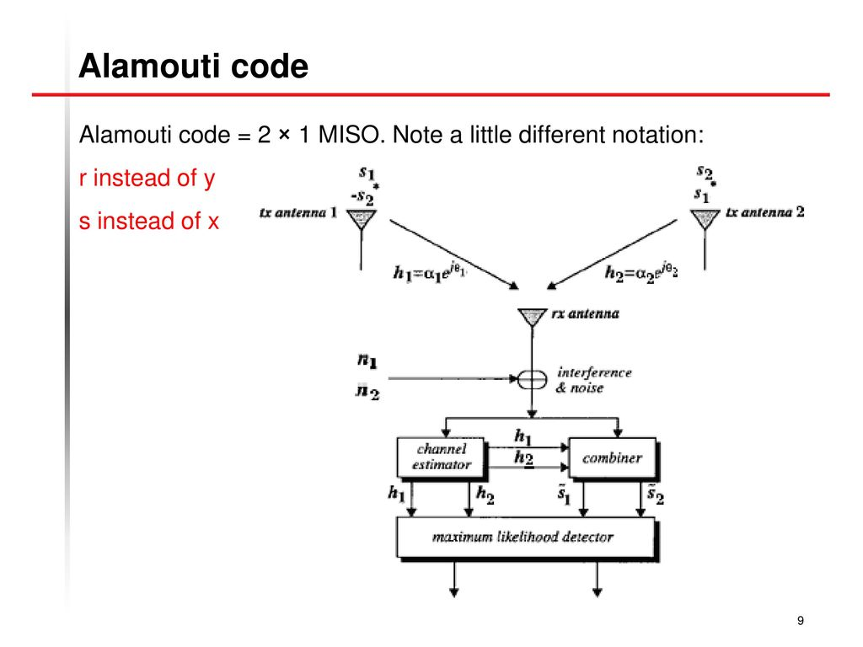

Block 4: Decoding of STBC

Block 4 gives the information about

In the decoder, the received signal is fed to the channel estimator. The estimated coefficients of the channel together with the combiner are given as the input to the maximum likelihood detector. The detected signal is then fed to the demodulator. The demodulator gives the original information which is transmitted.

**Binary Phase Shift Keying (BPSK)**

Block 5: BPSK Transmitter

Block 6: BPSK Receiver

Binary PSK Transmitter and Receiver:

To generate a binary PSK wave, input binary sequences are represented in polar form with symbols 1 and 0 by constant amplitude levels of +√𝐸𝑏 and −√𝐸𝑏 respectively. This binary wave and a sinusoidal carrier wave 𝛷1(𝑡) whose frequency fc=nc /T b for some fixed integer nc are applied to a product modulator as shown in block 5. The carrier and the timing pulses used to generate the binary wave are usually extracted from a common master clock. The desired PSK wave is obtained at the modulator output. To detect the original binary sequence of 1s and 0s, noisy PSK wave x(t) (at the channel output) is applied to a correlator, which is also supplied with a locally generated coherent reference signal 𝛷1(𝑡) as shown in block 6. The correlator output xi, is compared with a

threshold of zero volts. If x1>0, the receiver decides in

favor of symbol1. If x1<0, it decides in favor of symbol 0.

**Quadrature Amplitude Modulation (QAM)**

Block 7: QAM Transmitter

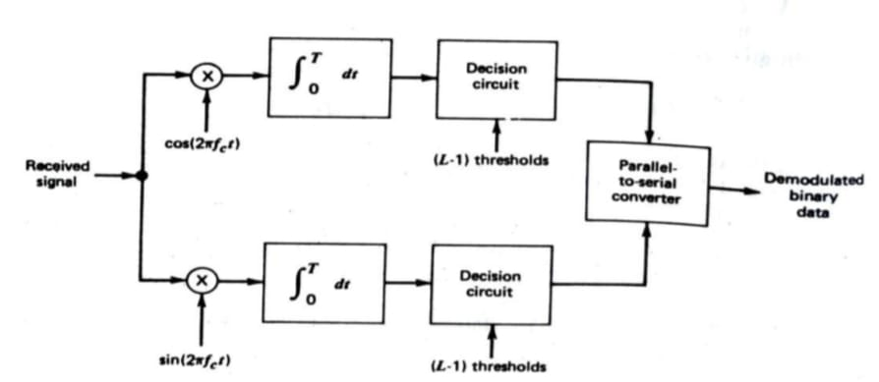

Block 8: QAM Reciver

QAM Transmitter and Receiver:

The serial-to-parallel converter accepts a binary sequence at a bit rate Rb=1/Tb and produces two parallel binary sequences whose bit rates are Rb/2 each. The 2-to- L level converters, where L= √𝑀, generate polarL-level signals in response to the respective in-phase and quadrature channel inputs. Quadrature-carrier multiplexing of the two polar L-level signals so generated produces the desired M-ary QAM signals as shown in block 7.

Block 8 shows diagram of receiver. Decoding of each baseband channel is accomplished at the output of the pertinent decision circuit, which is designed to compare the L-level signals against L-1 decision thresholds. The two binary sequences so detected are then combined in the parallel –to-serial converter to reproduce the original binary sequence.

**Block Diagrams**

Fig 1: BPSK without STBC

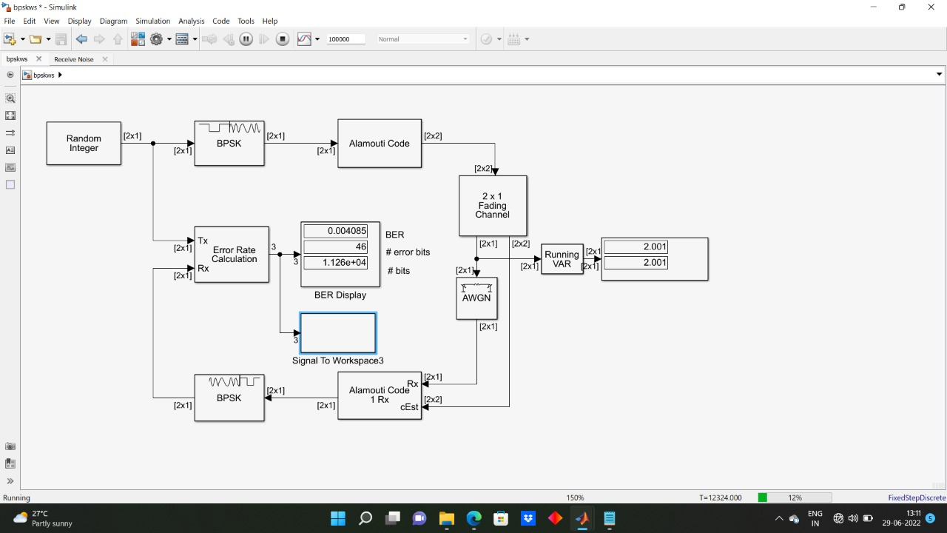

Fig 2: BPSK with STBC

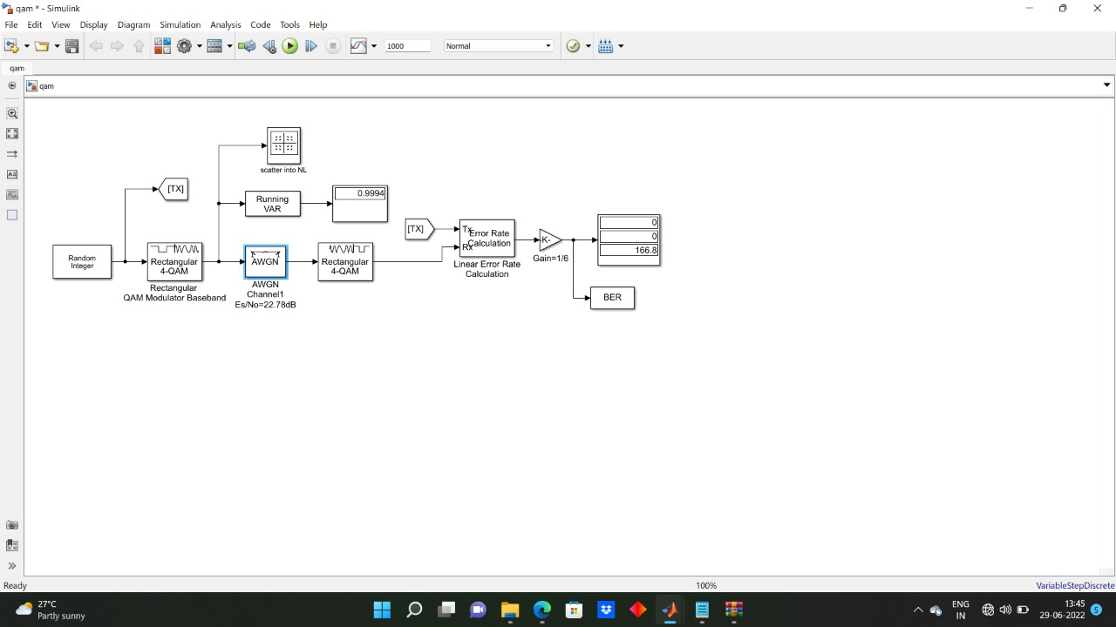

Fig 3: QAM without STBC

Fig 4: QAM with STBC

**Algorithm**

**Step 1:** The signal generated can be analog or digital.

**Step 2:** The generated signal is modulated respectively with phase and amplitude.

**Step 3:** Now the space time encoding occurs when the two transmitters transmit the signals.

**Step 4:** Now the signal is passed through Rayleigh fading channel .in this fading of the signal happens according to the radial component of sum of two uncorrelated Gaussian random variables.

**Step 5:** Now the white noise is added to the one the transmitter.

**Step 6:** As we have encoded the space time block codes now the decoding of this occurs in the combiner.

**Step 7:** As the signal is modulated earlier, demodulation is done in order to bring back the original signal.

**Step 8:** Now the comparison of the original signal and with the modulated space block coded signal occurs to determine the error bits.

**Working Principle**

Space-time block codes (STBC) are a generalized version of Alamouti scheme, but have the same key features. These codes are orthogonal and can achieve full transmit diversity specified by the number of transmit antennas. In other words, space-time block codes are a complex version of Alamouti’s space-time code, where the encoding and decoding schemes are the same as there in the Alamouti space-time code on both the transmitter and receiver sides. The data are constructed as a matrix which has its columns equal to the number of the transmit antennas and its rows equal to the number of the time slots required to transmit the data. At the receiver side, the signals received are first combined and then sent to the maximum likelihood detector where the decision rules are applied. Space-time block codes were designed to achieve the maximum diversity order for the given number of transmit and receive antennas subject to the constraint of having a simple linear decoding algorithm.

This has made space-time block codes a very popular and most widely used scheme. Training-based methods seem to give very good results on the performance of channel estimation at the receiver. Pure training-based schemes can be considered as an advantage when an accurate and reliable MIMO channel needs to be obtained. However, this could also be a disadvantage when bandwidth efficiency is required. This is because pure training-based schemes reduce the bandwidth efficiency considerably due to the use of a long training sequence which is necessarily needed in order to obtain a reliable MIMO channel estimate. Because of the computation complexity of blind and semi-blind methods, many wireless communication systems still use pilot sequences to estimate the channel parameters at the receiver side.

**Alamouti Scheme**

Alamouti scheme is the basis of the Space Time Coding technique. The mathematical explanation of the scheme with two transmitting and one receiving antennas is also explained here. In this work, a two-branch transmit diversity scheme is implemented. Using two transmit antennas and one receive antenna, the scheme provides the same diversity order as maximalratio receiver combining (MRRC) with one transmit antenna and two receive antennas. The scheme may easily be generalized to two transmit antennas and M receive antennas to provide a diversity order of 2M. At the transmitter side, a block of two symbols is taken from the source data and sent to the modulator. After that, Alamouti space-time encoder takes the two modulated symbols, in this case called s1 and s2 creates encoding matrix S where the symbols s1 and s2 are mapped to two transmit antennas in two transmit time slots. The encoding matrix is given by

S= s1 s2

–s2* s1*

The fading coefficients denoted by h1(t) and h2(t) are assumed constant across the two consecutive symbol transmission periods and they can be defined as:

h1(t) = h1(t+T) = h1 = |h1|ejθ1

h2(t) = h2(t+T) = h2 = |h2|ejθ2

The receiver receives r1 and r2 denoting the two received signals over the two consecutive symbol periods for time t and t+T. The received signals can be expressed by:

The maximum likelihood (ML) decoder chooses a pair of signals (ŝ1, ŝ2) from the signal constellation to minimize the distance metric over all possible values of ŝ1 and ŝ2.

d 2 (r1, h1ŝ1+h2ŝ2) + d2 (r2, -h1ŝ2* + h2ŝ1*) =

|r1-h1ŝ1-h2ŝ2| 2 + |r2+h1ŝ2*-h2ŝ1*|2

For phase-shift keying (PSK) signals, the decision rule can be expressed by:

d 2 (ŝ1, si) ≤ d2 (ŝ1, sk) ˅̶ i ≠ k

d 2 (ŝ2, si) ≤ d2 (s2, sk) ˅̶ i ≠ k

The combiner shown in Block 4 builds the following two combined signals that are sent to the maximum likelihood detector.

The encoder and decoder of the Alamouti scheme system is shown in Block 3 and Block 4. Here the information to be transmitted is modulated and fed to the space time encoder. The space time encoder consists of two transmit antennas as part of the multiple input multiple output technology . So here the information is transmitted through two separate antennas. Each transmitting and the receiving antenna pair has a channel, represented by different channel coefficients. These channel coefficients play a major role in the design of the system. As the number of antennas increases at both the ends of the channel, the complexity of the system also increases. In the decoder, the received signal is fed to the channel estimator. The estimated coefficients of the channel together with the combiner are given as the input to the maximum likelihood detector. The detected signal is then fed to the demodulator. The demodulator gives the original information which is transmitted. The space-time block codes are the higher version of the Alamouti scheme. i.e, increment of the number of antennas of the Alamouti scheme, the space-time block codes will result.

**Flowchart**

INPUT

(Analog/digital)

Input(analog/digital)

MODULATION

Modulation

STBC

encoding

DEMODULATION

STBC

Decoding

OUTPUT

Fig (a)

Demodulation

Fig 5 a: Flow-chart of the modulation

5 b: Flow chart of the modulation using STBC

Output

Fig (b)

**Chapter-3**

**Software tools &**

**Working of Blocks**

## Software Tool

The software tool used for the mini-project work is MATLAB with Simulink modeling.

MATLAB is a high-level language and interactive environment for numerical computation, visualization, and programming. Using MATLAB, you can analyze data, develop algorithms, and create models and applications. The language, tools, and built-in math functions enable you to explore multiple approaches and reach a solution faster than with spreadsheets or traditional programming languages, such as C/C++ or Java. MATLAB is an abbreviation for “matrix laboratory.” While other programming languages mostly work with numbers one at a time, MATLAB is designed to operate primarily on whole matrices and arrays.

Simulink is a block diagram environment for multidomain simulation and Model-Based Design. It supports system-level design, simulation, automatic code generation, and continuous test and verification of embedded systems. Simulink provides a graphical editor, customizable block libraries, and solvers for modeling and simulating dynamic systems. It is integrated with MATLAB, enabling you to incorporate MATLAB algorithms into models and export simulation results to MATLAB for further analysis. Upon gaining familiarity with Simulink, the user will discover that multiple paths can be followed in developing a Simulink model. The choice of the path is left to the user but each path will lead to the same solution. The topics covered are:

* Starting a MATLAB session
* Viewing Simulink block libraries
* Building a new Simulink model
* Setting simulation parameters
* Setting and using Scopes
* Executing the model
* Sending data to Workspace
* Using the Model Explorer
* Selecting Model Configuration Parameters

**Working**

1.We have used random integer generator in order to generate a uniformly distributed random integers in the range [0, M-1], where M is the Set size defined in the dialog box. The Set size can be either a scalar or a row vector. If it is a scalar, then all output random variables are independent and identically distributed (i.i.d.). If the Set size is a vector, then the length of the vector determines the number of output channels. The channels can have differing output ranges. If the Initial seed parameter is a constant, then the resulting noise is repeatable. The output signal can be a column or row vector, a two-dimensional matrix, or a scalar. The number of rows in the output signal corresponds to the number of samples in one frame and is determined by the Samples per frame parameter. The number of columns in the output signal corresponds to the number of channels and is determined by the number of elements in the Set size parameter.

2. The BPSK Modulator Baseband block modulates using the binary phase shift keying method. The output is a baseband representation of the modulated signal. This block accepts a column vector input signal. The input must be a discrete-time binary-valued signal. If the input bit is 0 or 1, respectively, then the modulated symbol is exp(jθ) or -exp(jθ), respectively, where θ represents the Phase offset parameter.

3. The BPSK Demodulator Baseband block demodulates a signal that was modulated using the binary phase shift keying method. The input is a baseband representation of the modulated signal. This block accepts a scalar or column vector input signal. The input signal must be be a discrete-time complex signal. The block maps the points exp(jθ) and -exp(jθ) to 0 and 1, respectively, where θ is the Phase offset parameter.

4. The AWGN Channel block adds white Gaussian noise to the input signal. It inherits the sample time from the input signal

5. The Error Rate Calculation block compares input data from a transmitter with input data from a receiver. It calculates the error rate as a running statistic by dividing the total number of unequal pairs of data elements by the total number of input data elements from one source. Use this block to compute either symbol or bit error rate, because it does not consider the magnitude of the difference between input data elements. If the inputs are bits, then the block computes the bit error rate. If the inputs are symbols, then it computes the symbol error rate

6. When you set the Output data parameter to Workspace, the block generates no code. Similarly, no data is saved to the workspace if the Simulation mode is set to Accelerator or Rapid Accelerator. If you need error rate information in these cases, set Output data to Port

7. The Complex to Real-Imag block outputs the real and/or imaginary part of the input signal, depending on the setting of the Output parameter. The real outputs are of the same data type as the complex input. The input can be an array (vectoror matrix) ofcomplex signals, in which case the output signals are arrays of the same dimensions. The real array contains the real parts of the corresponding complex input elements. The imaginary output similarly contains the imaginary parts of the input elements.

8. The OSTBC Encoder block encodes an input symbol sequence using orthogonal space-time block code (OSTBC). The block maps the input symbols block-wise and concatenates the output codeword matrices in the time domain The block supports time and spatial domains for OSTBC transmission. It also supports an optional dimension, over which the encoding calculation is independent. This dimension can be thought of as the frequency domain, any positive integer. N can be 2, 3 or 4, indicated by Number of transmit antennas. For N = 2, R must be 1. For N = 3 or 4, R can be 3/4 or 1/2, indicated by Rate. The time domain length T must be a multiple of the number of symbols in each codeword matrix. Specifically, for N = 2 or R = 1/2, T must be a multiple of 2 and when R = 3/4, T must be a multiple of 3

9. The OSTBC Combiner block combines the input signal (from all of the receive antennas) and the channel estimate signal to extract the soft information of the symbols that were encoded using an OSTBC. The input channel estimate may not be constant during each codeword block transmission and the combining algorithm uses only the estimate for the first symbol period per codeword block. A symbol demodulator or decoder would follow the Combiner block in a MIMO communications system The block conducts the combining operation for each symbol independently. The combining algorithm depends on the structure of the OSTBC For be any positive integers. M can be 1 through 8, indicated by the Number of receive antennas parameter. N can be 2, 3 or 4, indicated by the Number of transmit antennas parameter. The time domain length T/R must be a multiple of the codeword block length (2 for Alamouti; 4 for all other

OSTBC). For N = 2, T/R must be a multiple of 2. When N > 2, T/R must be a multiple of 4. R defaults to 1 for 2 antennas. R can be either (3,4 ^1,2) for more than 2 antennas. The supported dimensions for the block depend upon the values of F and M. For one receive antenna (M = 1), the received signal input must be a column vector or a full 2–D matrix, depending on the value for F. The corresponding channel estimate input must be full 2-D or 3-D matrix. For more than one receive antenna (M > 1), the received signal input must be a full 2-D or 3-D matrix, depending on the value for F. Correspondingly, the channel estimate input must be a 3-D or 4-D matrix, depending on the value for F.

10. The SISO Fading Channel block filters an input signal using a single-input/single-output (SISO) multipath fading channel. This block models both Rayleigh and Rician fading

11. The Rectangular QAM Modulator Baseband block modulates using M-ary quadrature amplitude modulation with a constellation on a rectangular lattice. The output is a baseband representation of the modulated signal. This blockaccepts a scalar or column vector input signal. For information about the data types each block port supports.

12. When you set the Input type parameter to Integer, the block accepts integer values between 0 and M-1. M represents the M-ary number block parameter. When you set the Input type parameter to Bit, the block accepts binary-valued inputs that represent integers. The block collects binary-valued signals into groups of K = log2(M) bits where K represents the number of bits per symbol. The input vector length must be an integer multiple of K. In this configuration, the block accepts a group of K bits and maps that group onto a symbol at the block output. The block outputs one modulated symbol for each group of K bits. The Constellation ordering parameter indicates how the block assigns binary words to points of the signal constellation. Such assignments apply independently to the in-phase and quadrature components of the input:

* If Constellation ordering is set to Binary, the block uses a natural binary-coded constellation.
* If Constellation ordering is set to Gray and K is even, the block uses a Gray-coded constellation.
* If Constellation ordering is set to Gray and K is odd, the block codes the constellation so that pairs of nearest points differ in one or two bits. The constellation is cross-shaped, and the schematic below indicates which pairs of points differ in two bits. The schematic uses M = 128, but suggests the general case.

13. The Rectangular QAM Demodulator Baseband block demodulates a signal that was modulated using quadrature amplitude modulation with a constellation on a rectangular lattice. The signal constellation has M points, where M is the M-ary number parameter. M must have the form 2K for some positive integer K. The block scales the signal constellation based on how you set the Normalization method parameter. This block accepts a scalar or column vector input signal.

# Chapter-4

**Results and Discussions**

Fig 6: BER curve of BPSK with and without STBC

Figure 6 shows simulations of BPSK with and without STBC. Here we can observe that AWGN is more efficient than Rayleigh channel. So we will simulated QAM in AWGN.

Fig 7: BER curve of QAM with and without STBC

Here from figure 5 and 6 we observe that BPSK is more efficient than QAM

# Chapter-5

**Applications, Advantages, Outcome and Limitations**

**APPLICATIONS**

* The STBC technique is combined with QPPM modulation and be used in atmosphere laser communication
* The STBCs are to be used at the receiver side to improve the accuracy of the localization. The improvement in positioning accuracy is essential especially for computer embroidery machine
* Efficient Diversity Techniques Using STBC for Multi-Carrier Systems
* STBC in free space optical communications system

**ADVANTAGES**

* The main advantages of MIMO systems using STBC are higher data rate and higher reliability without the need of extra power and bandwidth.
* The MIMO system using STBC i provides higher data rate by using spatial multiplexing technique and higher reliability by using diversity technique
* Performance of a MIMO system using STBC is heavily impacted on the number of antennas being used for transmissions
* .signals can convey information with less noise, distortion, and interference.
* Digital systems are more accurate, and therefore the probability of error occurrence are often reduced by employing error detection and correction codes.
* STBC with spatial multiplexing for MIMO transmission results in performance enhancements, such as in high throughput WLANs.

**OUTCOMES**

* The performances of space-time block codes on MIMO fading channels using different modulation methods were simulated
* A new joint channel estimation and data detection scheme was proposed and different implementations and simulation results were presented.
* The channel parameters were estimated continuously, at first, the channel parameters were estimated using the transmitted pilot sequence. In the second time and after, the channel parameters were estimated using the previous detected user data information
* The scheme in general gave out a bit-error-rate loss of 3dB , the main advantage here is system becomes more efficient.

**LIMITATIONS**

* The main disadvantage of MIMO system is that the multiple antennas required extra High Cost RF modules.
* The extra RF modules increase the cost of wireless communication systems

# Chapter-6

**Conclusions and Future Work**

This paper gives a basic overview of the MIMO technology. We discussed block codes with code rate of 2 by 1. We optimized rate one design to achieve minimum BER for Rayleigh fading channel realization when the information symbols are drawn from BPSK and QAM digital modulation technique. Also, we plot the BER curves for BPSK and QAM modulation in Rayleigh fading channels without using STBC. Finally, we conclude that BPSK Modulation gives sharp waterfall curve with trade-off of one bit per symbol. Whereas QAM modulation gives steady BER curve. A basic introduction to Space-Time Coding has been provided by presenting Alamouti’s scheme. The Alamouti scheme has been simulated for BPSK modulation in Rayleigh channel. The same Alamouti scheme has been again simulated in Rayleigh channel for 4-QAM and 16-QAM modulations and the BER are compared. After that the BER of Orthogonal Space-Time Block Coding that has 4 International Journal of Distributed and Parallel Systems (IJDPS) Vol.3, No.4, July 2012 194 number of transmit antennas has been determined for different code rates and modulation (BPSK, 16-QAM, 4-QAM). We observed that BER reduces as no. of antennas are increases but it reduce the energy per receive antenna. The better BER curve produced by a system which uses more number of antennas at both sides of the communication link. A particular application decides which modulation can be used. For example, in technologies like TV satellite transmission, higher modulation methods (256-QAM and 512-QAM) could be employed because the accuracy of received data at the user end is not essential. Other correction techniques could be employed to improve the performance of such systems. However, in mobile technology, the bit error-rate is very important. In this case, accuracy is essential. Therefore, lower order modulation methods are usually employed. So the application decides which modulation and the combination of antennas in the communication link. Finally as a future expansion of this paper, it is possible to introduce different modulation schemes to increase the data rates. Also we can increase the number of antennas at both transmitter and receiver without introducing any interference in between the antennas.

# References

1. Daniel W. Bliss, Keith W. Forsythe, and Amanda M. C “MIMO Wireless Communication “, Lincoln Laboratory Journal , Vol.15, No.1, 2005.

2. V. Tarokh, N. Seshadri, and A. Calderbank, “Space-time block codes from orthogonal designs”, IEEE Trans. Information Theory, vol. 45, pp. 1456–1467, July 1999.

3. S. Alamouti, “A simple transmit diversity technique for wireless communications”, IEEE Journal on Selected Areas in Communications, vol. 16, pp. 1451–1458, Oct 1998.

4. C. Fragouli, N. Al-Dhahir, and W. Turin, “Training-based Channel Estimation for Multiple-antenna Broadband Transmissions”, IEEE Transactions on Wireless Communications, Vol. 2, No. 2, March 2003.

5. Marcelo M. Carvalho & J. J. Garcia-Luna-Aceves.,” Analytical modelling of ad-hoc networks that utilize space time coding”, 4th International Symposium on AdHoc and Wireless Networks, IEEE, 2006

6. David Gesbert, Mansoor Shafi, Da-shan Shiu, Peter J. Smith, and Ayman Naguib, “From Theory to Practice: An Overview of MIMO Space–Time Coded Wireless Systems”, IEEE journal on selected areas in communications, vol. 21, no. 3, April 2003

7. V. Tarokh, N. Seshadri, and A. Calderbank, “Space-time codes for high data rate wireless communications: Performance criterion and code construction”, IEEE Trans. Information Theory, vol. 44, pp. 744–765, Mar 1998

8. B. M. Hochwald and T. L. Marzetta, “Unitary Space-time Modulation for Multiple Antenna Communications in Rayleigh Flat Fading,” IEEE Transactions on Information Theory, Vol. 46, No. 2, pp. 543-564, March 2000.

9. Andrea Goldsmith,“Wireless Communications”, Stanford University, Cambridge University Press, 2005.

10. Marcelo M. Carvalho & J. J. Garcia-Luna-Aceves, “Modeling Wireless AdHoc Networks with Directional Antennas”, IEEE Trans. Information Theory, vol. 47, pp. 846–868, Mar 2000.

11. Ming Hu and Junshan Zhang, “MIMO Ad Hoc Networks: Medium Access Control, Saturation Throughput and Optimal Hop Distance”, IEEE Trans. Information Theory, vol. 34, pp. 367–380, Mar 2004

12. Gerald W. Recktenwald ,“Numerical Methods with Matlab: Implementations and Applications”, Prentice-Hall, 2001.

13. J. Wu and Gary J. Saulnier, “Orthogonal Space-time Block Code Over Time-varying Flat-fading Channels: Channel Estimation, Detection, and Performance Analysis”, IEEE Transactions on Communications, Vol. 55, no. 5, May 2007. International Journal of Distributed and Parallel Systems (IJDPS) Vol.3, No.4, July 2012 195

14. G. J. Foschini and M. J. Gans, “On Limits of Wireless Communications in a Fading Environment When using Multiple Antennas”, Wireless Personal Communications, Vol. 6, pp. 311-335, 1998.

15. A. Molisch, “Wireless Communications”, Wiley-IEEE Press, 2005.

# 

# Paper presented / Publications / Awards during the tenure of the UG program’s Mini-Project Work

A copy of the presented paper can be attached here ….. in the form of IEEE format & the full paper.

Format :

Name/s of the author/s, “Title of the paper”, *Name of the Journal / Conference*, ISBN, ISSN, Vol. xx, Issue/No. yy, pp. aa-bb, Month, Year.

Attach a copy of the paper presented or published here.

If the student has participated in any project exhibition inside or outside the college, the certificate of participation & if any award or best mini project is declared, then that certificate, etc.. has to be attached at the end of the mini-project report.

Certificate of participation, presentation can be inserted here.

Certificates of the project competitions won @ various colleges can also be inserted here.

# Photographs

Photographs can be put here …. Coloured & titled

# Instructions to the students

The students should follow the instructions while submitting the mini-project report. ***Get the mini-project report checked from the concerned guide, after getting it approved with the sign, then only proceed towards the printing.***

**No. of copies :** 1 to each student, 1 to guide.

**No. of pages :** Minimum 25 pages to 100 pages maximum.

**Note 1 :** References to be in standard IEEE format only.

**Note 2 :** While presentation, follow the dress code with formals or uniform with ID card **Note 3 :** All the mentioned items previously has to be started on a fresh page (*single sided*), the contents of the items should be in 11 font, Book Antiqua, 1.5 line spacing, left margin 1.25”, right margin 1”, A4 size paper, single sided matter, replace the contents given in the items with your work details. Every page should be paragraphed, indented & should contain minimum of 2-3 paragraphs. Each chapter should begin on a fresh page. The final corrected & approved mini-project report should be taken a **laser print out on executive white bond paper, hard bounded** & submitted to the mini-project guide, mini-project section coordinator, mini-project convener & chief coordinator, Dept. HOD for final possible corrections, approvals, signatures & final submissions.

## Note 3 :

* All chapter headings – 18 Font.
* All Sub-chapter headings or sub-sections – 16 Font.
* All text-matter : 11 Font.
* All figure & table titles : 10 Font.
* All References : 10 Font.
* Entire body of the mini-project report : 1.5 Line Spacing
* For all the pages of the mini-project report, from the table of contents till the end, the header & the footer should be there, except for the title page of the mini-project.
* Page numbering should start from chapter-1, i.e., 1, 2, 3…. & the starting sheets should be numbered in roman numbers, i.e., i, ii, iii, iv, v,…..
* The mini-project report should be soft-binded, back coloured sheet, front transparent sheet, pinned & a brown tape put @ the side, i.e., the mini-project reports submitted to the department/guide(s) must be soft-binded, with a plastic covering.
* Buff sheets (separator sheets), used if any, between chapters, should be of thin paper (similar to the one which comes in transparency sheets in between) with the entire page written as chapter number, below the title of the chapter can be written.
* All equation numbers should be numbered & right justified, the equation should be in the middle (use the middle tab) & the equation number to be at the right (use the right tab).
* The mini-project report should be brief and include descriptions of work carried out by others only to the minimum extent necessary.
* Verbatim reproduction of material available elsewhere should be strictly avoided and if used should be cited properly and mentioned in the reference section.
* Where short excerpts from published work are desired to be included, they should be within quotation marks appropriately referenced.
* Proper attention is to be paid not only to the technical contents, but also to the organization of the mini-project report and clarity of the expression.
* Due care should be taken to avoid spelling and typographical errors.
* The student should note that mini project report-write-up forms the important component in the overall evaluation of the mini-project, which is of 2 credits.
* COs POs Budget Cost estimation should be submitted.
* Hardware based mini-projects must include : the component layout, complete circuit with the component list containing the name of the component, numbers used, etc. and the main component data sheets as Appendix.
* Software based mini-projects must include a virus free disc, containing the software developed by them along with the read me file.
* Hardware & Software based mini-projects should include both the above 2 points.

Read me file should contain the details of the variables used, salient features of the software and procedure of using them: compiling procedure, details of the computer hardware / software requirements to run the same, etc.

* A CD/DVD has to be put at the end of the report incorporating all the codes, word files, pdf files, references used, software, paper presentations, ppts, review & final phase ppts, GUIs, word format of the mini-project report, photographs, etc…